QUESTION – 1

We know singular values of $A$ are the square root of the eigenvalues of $AA^{T}$ and $A^{T}A$.

$$A=UΣV^{T}$$

$$A^{T}={\left(UΣV^{T}\right)}^{T}=VΣ^{T}U^{T}$$

We know $Σ^{T}= Σ$ since it is a diagonal matrix. We also know $U^{T}=U^{-1}$ and $V^{T}=V^{-1}$ since they are orthogonal matrices. $$AA^{T}=XΛX^{-1}$$

$$\left(UΣV^{T}\right)\left(VΣ^{T}U^{T}\right)=UΣ\left(V^{T}V\right)ΣU^{T}= UΣIΣU^{T}=UΣ^{2}U^{T}=XΛX^{-1}$$

Thus equation

$$Σ^{2}=Λ$$

can be obtained which concludes that SVD decomposition gives square root of eigenvalues of $AA^{T}$ which are the singular values of $A$. $$A^{T}A=YΛY^{-1}$$

$$A^{T}A=\left(VΣU^{T}\right)\left(UΣV^{T}\right)=VΣ{(U}^{T}U{)ΣV}^{T}=VΣ{IΣV}^{T}=VΣ^{2}V^{T} = YΛY^{-1}$$

Thus equation

$$Σ^{2}=Λ$$

can be obtained which again concludes that SVD decomposition gives square root of eigenvalues of $A^{T}A$ which are the singular values of $A$.

QUESTION – 2

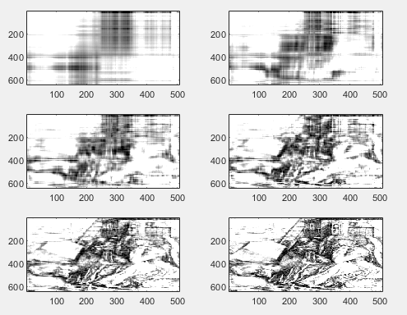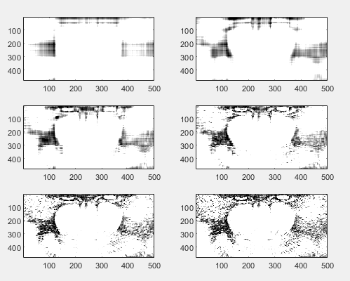a-)

Figure 1: Mandrill image compressed with truncated SVD, with r values ranging from $2^{1}$ to $2^{6}$

Figure 1: Drawing of Albrecht Dürer compressed with truncated SVD, with r values ranging from $2^{1}$ to $2^{6}$

close all

figure()

colormap(gray);

load mandrill;

[U,S,V] = svd(X);

for i = 1:6

r = 2.^i;

subplot(3,2,i), image(U(:,1:r)*S(1:r,1:r)*V(:,1:r)');

end

figure()

colormap(gray);

load durer;

[U,S,V] = svd(X);

colormap(gray)

for i = 1:6

r = 2.^i;

subplot(3,2,i), image(U(:,1:r)*S(1:r,1:r)*V(:,1:r)');

end

b-) For both images until r = 32 image looks way too blurry to understand anything from it. For higher r values drawing of Dürer looks better and more detailed than the Mandrill image since original image contains more details. For lower r values Mandrill looks better since it does not have many details, thus required singular values to make a reasonable image is much less than the singular values required by Dürer’s drawing.

Original Mandrill image is a 480x500 image which takes 1 byte per pixel thus takes $480×500 = 225,000$ bytes to store. After compression the storage that is required can be calculated by

$$f\left(r\right)=r×\left(500+480+1\right)$$

Original Durer image is a 648x509 image thus takes $648×509 =329,832$ bytes to store. Required storage can be calculated by

$$g\left(r\right)=r×\left(648+509+1\right)$$

QUESTION – 3

function vk = power_method(inputMatrix, initialGuess, iterationCount)

vk = initialGuess;

for i = 1:iterationCount

tmp = inputMatrix * vk;

vk = tmp / norm(tmp);

disp(-vk);

end

end

A = [-2 1 4; 1 1 1; 4 1 -2];

v0 = [1; 2; -1];

vt = [1; 2; 1];

power_method(A,v0,20);

power_method(A,vt,5);

|  |  |  |  |  |  |
| --- | --- | --- | --- | --- | --- |
| Iteration | 1 | 2 | 3 | 4 | 5 |
| $$V0={\left(1,2,-1\right)}^{T}$$ | 0.4364  -0.2182  -0.8729 | -0.8083  -0.1155  0.5774 | 0.6448  -0.0586  -0.7621 | -0.7356  -0.0294  0.6768 | 0.6922  -0.0147  -0.7216 |
| $$V0={\left(1,2,1\right)}^{T}$$ | -0.5774  -0.5774  -0.5774 | -0.5774  -0.5774  -0.5774 | -0.5774  -0.5774  -0.5774 | -0.5774  -0.5774  -0.5774 | -0.5774  -0.5774  -0.5774 |

For $V0{\left(1,2,1\right)}^{T}$ power method found the eigenvector on the first iteration. $V0={\left(1,2,-1\right)}^{T}$ seems like converging but it requires more steps.

[V, D] = eig(A)

V = 0.7071 0.4082 -0.5774

0 -0.8165 -0.5774

-0.7071 0.4082 -0.5774

D = -6.0000 0 0

0 0.0000 0

0 0 3.0000